./

Learning Report

Embedded Linux

|  |  |  |
| --- | --- | --- |
| **Name** | **PS Number** | **Email ID** |
| Sampreeth Rayadurga | 99002500 | sampreeth.rayadurga@ltts.com |

Contents 3

Learning Objectives of the Module 4

**Activity 1** – Setup 4

**Activity 2** – Differences between Raspberry pie , Dragon, imx7 Sabre, BBB 6

**Activity 3** – Evolution and Changes of Beagle back Bone Board 8

**Activity 4** – Pin expansion header of BBB and locate the various peripherals of Bone. 10

**Activity 5** – **Testing MLO image on BBB and Testing U-boot image on BBB**11

**Activity 6** – **Different booting stages in Beaglebone Black 1****2**

1. ROM Bootloader (RBL) 12

2. Secondary Program Loader/ MLO 13

3. U-Boot14

**Activity 7-Learn and quote the Linux boot sequence after the booting.** **15**

**Activity 8-Challenge-Make uEnv.txt to Boot from MMC0 and MMC 1 .** **18**

**Activity 9-Challenge-Write a uEnvt.txt file to automate TFTP boot.** **19**

**Activity 10-Challenge-Write a generic uEnv.txt 2****0**

**Activity 11-Challenge-Increase the AUTOLOAD timings . 2****1**

**Activity 12-Challenge-Busybox "Dynamic" Compilation 2****3**

**References 2****7**

# ACTIVITY 1:SETUP

**Step by Step Configuration of the boards and set up in Linux OS:**

**Step 1:** sudo minicom -s

**Step 2:** serial port setup (know the TTL cable name)

(In other terminal)

**Step 3:**  dmesg (Search for Prolific Technology) port ttyUSB0

**Step 4:** Press a and enter /dev/ttyUSB0

**Step 5:**  Press e check for Standard Baud rate : 115200 8N1

8-bit

N-no parity

1-Stop bit

**Step 6:**  Press f, Check for Hardware flow control set it to NO

**Step 7:**  Press g, Check for software flow control set it to NO

**Step 8:**  Save the settings as dfl (default)

**Step 9:**  Exit

**Step 10:** connect usb

ANGSTROM

**Step 11:**  beaglebone login: root

root@beaglebone:~#

**Step 12:** Shutdownnow

# Activity 2: Differences between Raspberry pie , Dragon, imx7 Sabre, BBB

|  |  |  |  |  |
| --- | --- | --- | --- | --- |
| **Parameter** | **RASPBERRY PIE** | **BEAGLEBONE BLACK** | **Dragon** | **imx7 Sabre** |
| ***Processor Type*** | It uses ARM11 processor. | It uses ARM Cortex-A8 processor. | Quad-core ARM® Cortex® A53 at up to 1.2 GHz per core with both 32-bit and 64-bit supporT | Two Arm Cortex-A7 core OS upto 1 GHz, Single Arm Cortex- M4 CORE os |
| ***RAM*** | For the functioning of raspberry pi, 512 MB SDRAM is used. | For the functioning of beaglebone black, 512 MB DDR3L is used. | 1GB LPDDR3 533MHz / 8GB eMMC 4.5 / SD 3.0 (UHS-I) | 1 GB DDR3, 533 MHz  eMMC expansion footprint. |
| ***Processor Speed*** | It uses 700 MHz for processing. | It uses 1 GHz for its processing. | 1.2 GHz per core with both 32-bit and 64-bit support | 1 GHz :Arm Cortex-A7  200 MHz :Arm Cortex -M4 |
| ***Minimum Power*** | It requires a power supply of 700mA (3.5W). | It requires min power of 210mA (1.05W) for its functioning. | It requires a power supply of 8-18V 2A. | It requires 5V/5A universal power supply. |
| ***GPIO Pins*** | It has 12 GPIO pins. | It has 69 GPIO pins. | It has 40 GPIO pins | It has 138 GPIO pins |
| ***USB Master*** | It has 2 USB 2.0 on board. | It has 1 USB 2.0 on its board. | one micro USB (device mode only), two USB 2.0 (host mode only) | * 1 USB host connector * 1 micro USB OTG connector |
| ***UART*** | It uses 1 UART to transmit and receive serial data. | It uses 5 UART to transmit and receive serial data. | support for one SoC UART and an optional second UART both to be routed to the Low Speed Expansion Connector. | UART via USB port |
| ***No. of I/O pins*** | It has 8 Digital, 0 Analog pins. | It has 65 Digital, 7 Analog pins. | It has 11 Digital ,0 Analog pins. | It has total 138 pins |

# Activity 3:Evolution and Changes of Beagle back Bone Board

|  |  |
| --- | --- |
| **Revision** | **Additions(differences)** |
| A4 | Preliminary |
| A4A | Incorporated the capacitors to fix the noise issue on the display |
| A4B | Added a 100K pull down resistor between pins 1 and 4 of J1 to fix the serial port issue |
| A5.1 | 1.Added information on Power button and the battery access  points  2.Final production released version. |
| A5.2 | 1) Updated the PCB to incorporate the modification that was being done on Rev A5A. There is NO difference at all in functionality between REV A5A and REV A5B. 2) Made the LEDs dimmer for those that could not sleep due to the brightness of the LEDs. |
| A5.3 | 1. Updated serial number locations.  2. Corrected the feature table for 4 UARTS  3. Corrected eMMC pin table to match other tables in the manual. |
| A5.4 | 1. Corrected revision listed in section 2. Rev A5A is the initial  production release.  2. Added all the locations of the serial numbers  3. Made additions to the compatibility list.  4. Corrected Table 7 for LED GPIO pins.  5. Fixed several typos.  6. Added some additional information about LDOs and Step-Down converters.  7. Added short section on HDMI. |
| A5.5 | 1. Release of the A5B version.  2. The LEDS were dimmed by changing the resistors.  3. The serial termination mode was incorporated into the PCB. |
| A5.6 | 1. Added information on Rev A5C  2. Added PRU/ICSS options to tables for P8 and P9.  3. Added section on USB Host  4. Correct modes on Table 15.  5. Fixed a few typos |
| A5.7 | 1. Updated assembly revision to A6.  2. PCB change to add buffer to the reset line and ground the oscillator GND pin.  3. Added resistor on PCB for connection of OSC_GND to board GND. |
| A6 | 1. Added changes for rev A6 that covered fixing of the link LED, JTAG Reset, and DHCP issue.  2. Added PRU information and two additional signals for the PRU.  3. Added write protection to EEPROM.  4. Fixed numbering of subsections in Section 7.0  5.Fixed error in Table 9 pin 23Mode 1 should be MMC1_DAT4.  6. Updated Table 7 to show the revision number in the EEPROM matches the revision of the board.  7. Corrected various typos.  8. Updated Battery Interface section to accurately document the LDO dropout at 200mV.  9. Added SW Support section. |
| A6A | 1) Added optional zero ohm resistor to tie GND_OSC1 to system ground. 2) Changed C106 to a 1uF capacitor. 3) Changed C24 to a 2.2uF capacitor. |
| B | 1.Changed the processor to the AM3358BZCZ  2.No changes in features or operation of the board resulted from this change. |
| C | 1.This revision increased the eMMC from 2GB to 4GB |

# Activity 4: Pin expansion header of BBB and locate the various peripherals of Bone.

# Activity-5: **Testing MLO and U-boot image on BBB**

1. -> Download gparted.
2. -> Put sdcard into card reader and then select sdcard and make it into 2 partitions.
3. -> Choose FAT16 file system for partition 1 and give label as BOOT.
4. -> For second partition name it as ROOTFS and then choose ext3/ext4 file system
5. -> Right click on BOOT and select manage flags then select boot option and then close.
6. -> Connect the RX of TTL cable to TX of BBB board, TX of TTL cable to RX of BBB board and connect the common ground.
7. -> Copy the MLO file in BOOT
8. -> Unmount SD card and then put it inside BBB and open terminal.
9. -> Install minicom and then do sudo minicom -s for setup changes and then save changes.
10. -> Copy the u-boot.img to the BOOT partition and repeat the step for boot-up
11. -> Open minicom and boot BBB with S2 pressed.

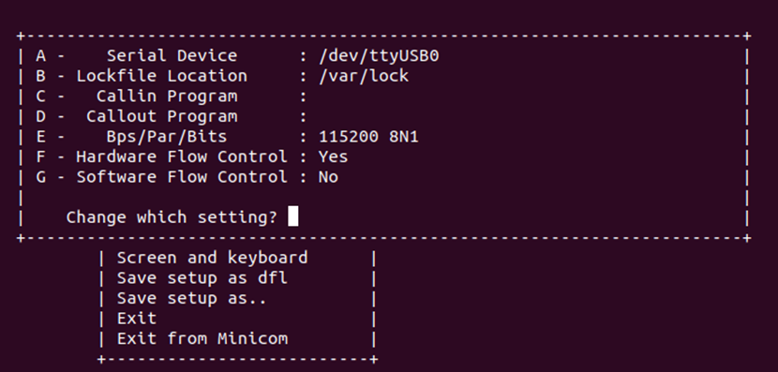

Figure 1: Serial device select

# Activity 6:Different booting stages in Beaglebone Black

### 1. **ROM Bootloader (RBL)**

The ROM boot loader for the BBB is located at the AM335x ROM. The AM335x have an internal RAM memory of 128KB. As soon as the power is applied to the device, the code at this location is executed. When we apply power to the SOC, it does some system level initializations and then goes for the initialization of the watchdog. The watchdog is configured for 3 minutes. If the watchdog is not fed for some time, watchdog senses some trouble and it will reset the system. So here, if even after three minutes the booting is not further connected to the SPL/MLO, the watchdog resets the system and the sequences restarts from the beginning.

If the device is not able to find any bootable image, the device will go into a dead loop and after three minutes, the watchdog will reset the system.

### 2. **Secondary Program Loader/ MLO**

The SOC will do the initializations and preparations for the U-Boot that is the third stage bootloader to be executed. It is also possible to modify the PLL in order to derive a desired frequency of clock source from the second stage bootloader. It also initializes the DDR memory because the Linux Kernel is going to be executed from this memory.

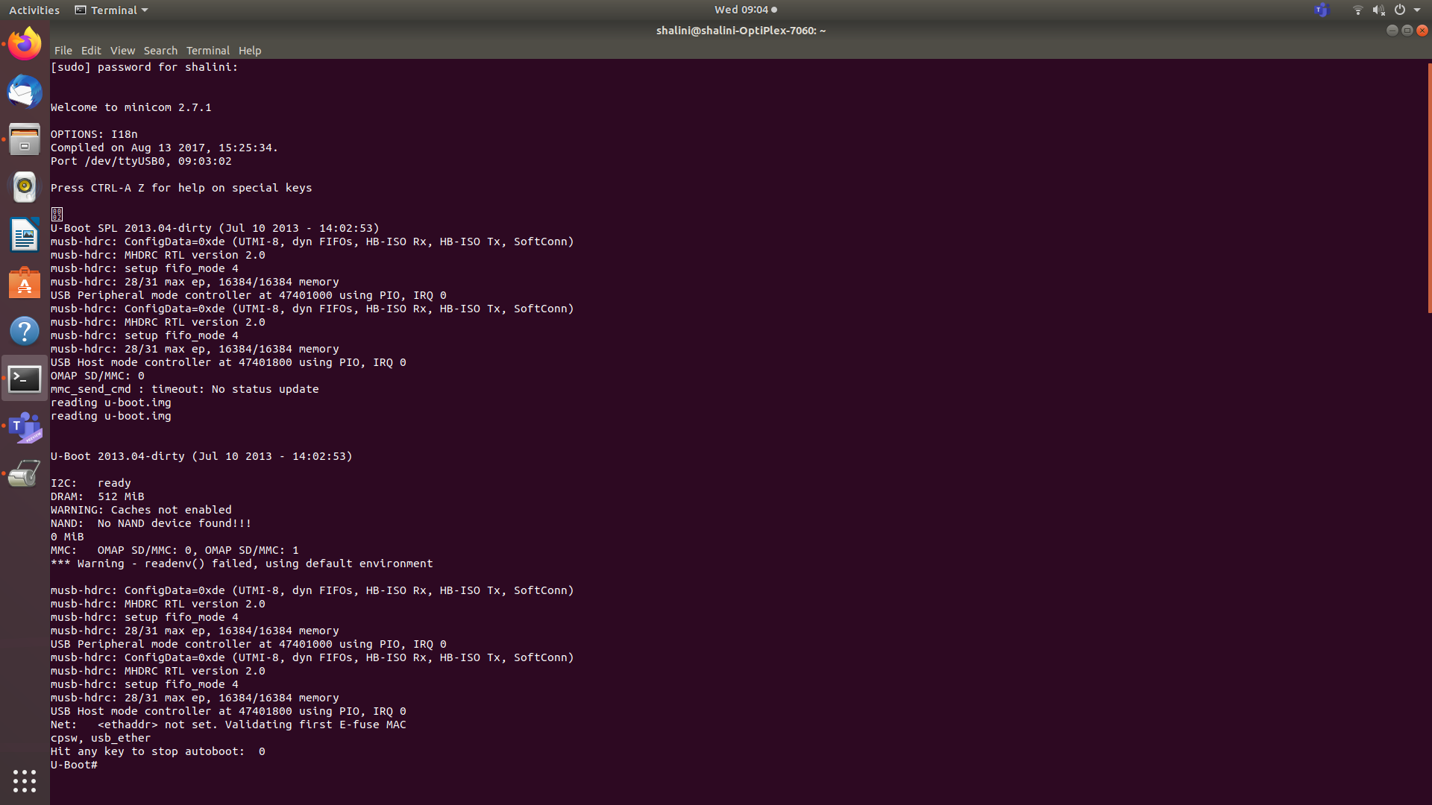

Figure 2: Booting till U-Boot

The RBL could not copy the U-Boot to the internal SRAM because the size of the internal SRAM is only 128KB. So we are using a second stage bootloader to copy the U-Boot to the DDR. Also, the U-Boot cannot be loaded directly to the DDR by the RBL, because DDR is an external memory. The SOC doesn’t know which DDR is being used.

### 3. **U-Boot**

Now the control have reached the third stage bootloader that is the U-Boot. T. In order for the U-Boot to load the Linux Kernel, we should tell the U-Boot where the Linux Kernel is located, through what interface it is accessible etc. With these information, the U-Boot will load the Linux Kernel into the DDR memory of the BBB.

We write these information in a file called uEnv.txt and the U-Boot will read this text file and find out from where it can load the Linux Kernel and to which address of the DDR memory is the Kernel to be loaded.

The U-Boot checks for a file called uImage.

# Activity-7: Linux boot sequence after the booting.

* By default, the ROM will boot from the MMC1 interface first (the onboard eMMC), followed by MMC0 (MicroSD), UART0 and USB0.
* If the boot switch (S2) is held down during power-up, the ROM will boot from the SPI0 Interface first, followed by MMC0, USB0 and UART0. This allows the BeagleBone Black to bypass the onboard eMMC and boot from the removable uSD (provided no valid boot device is found on SPI0.) This can be used to recover from a corrupted onboard eMMC.
* MLO Booting (uBoot SPL Second Program Loader)

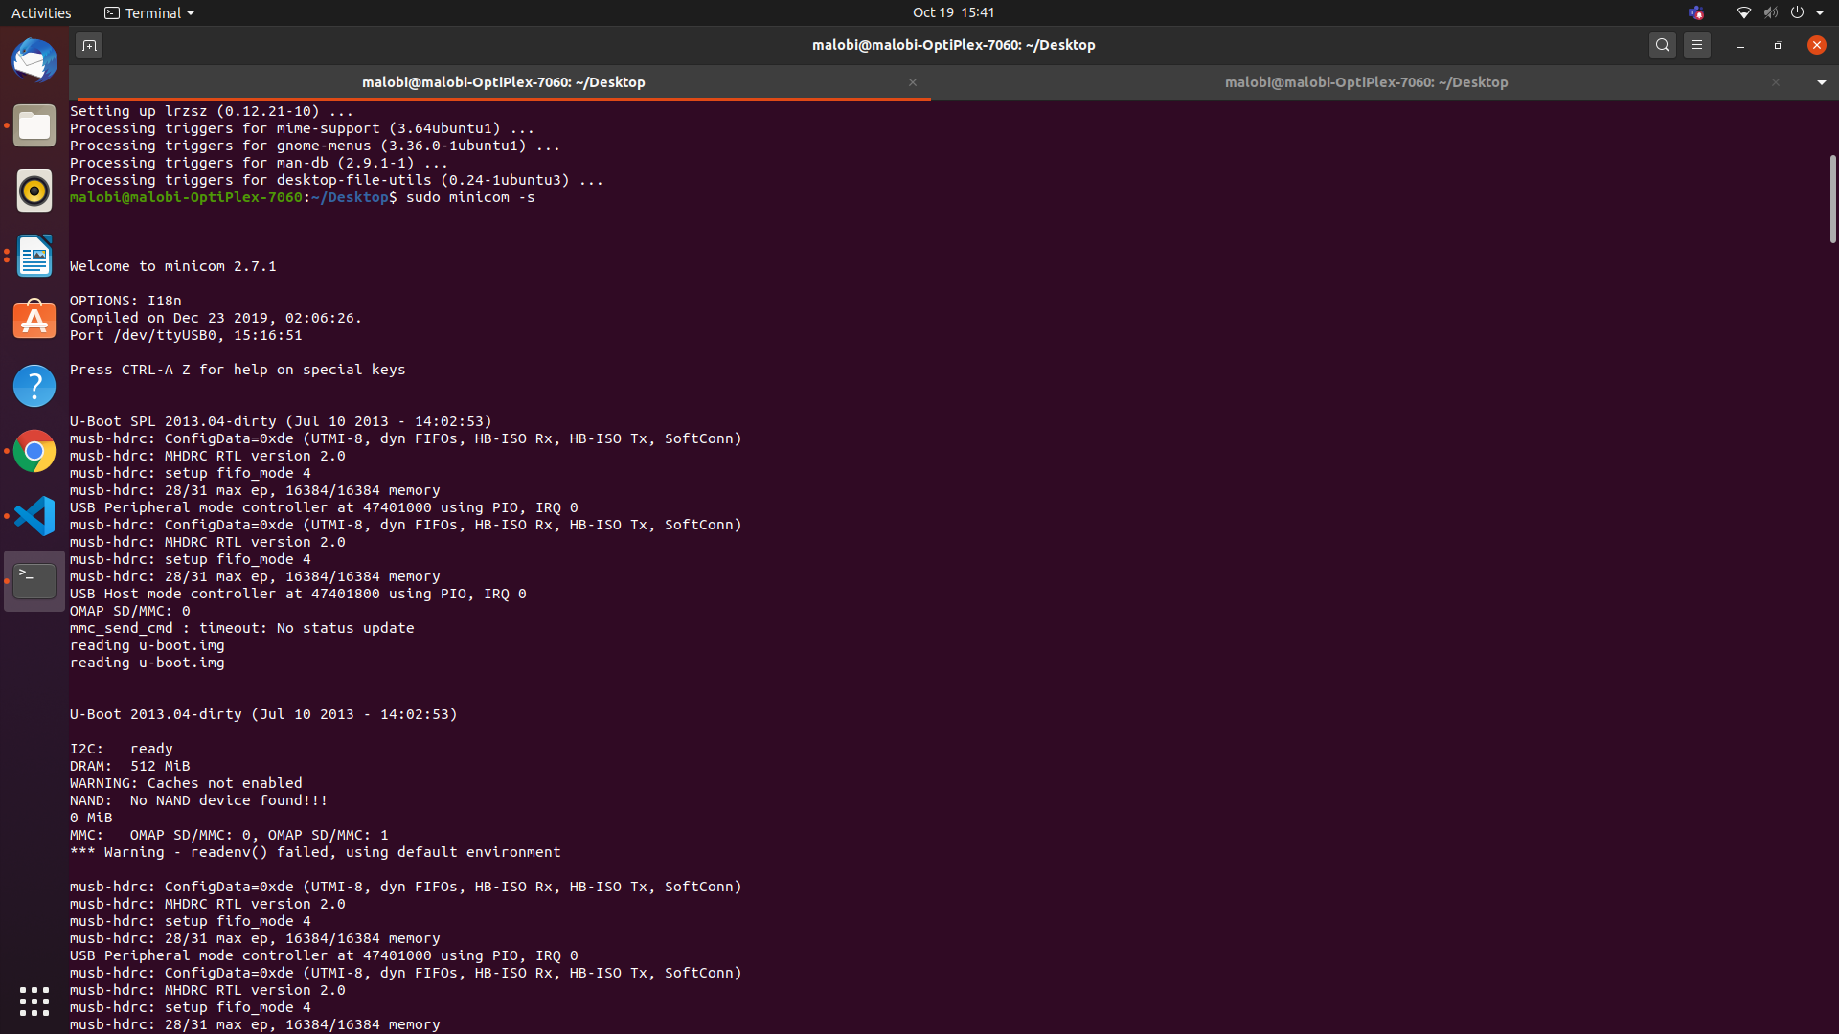

Figure 3: Loading u-boot

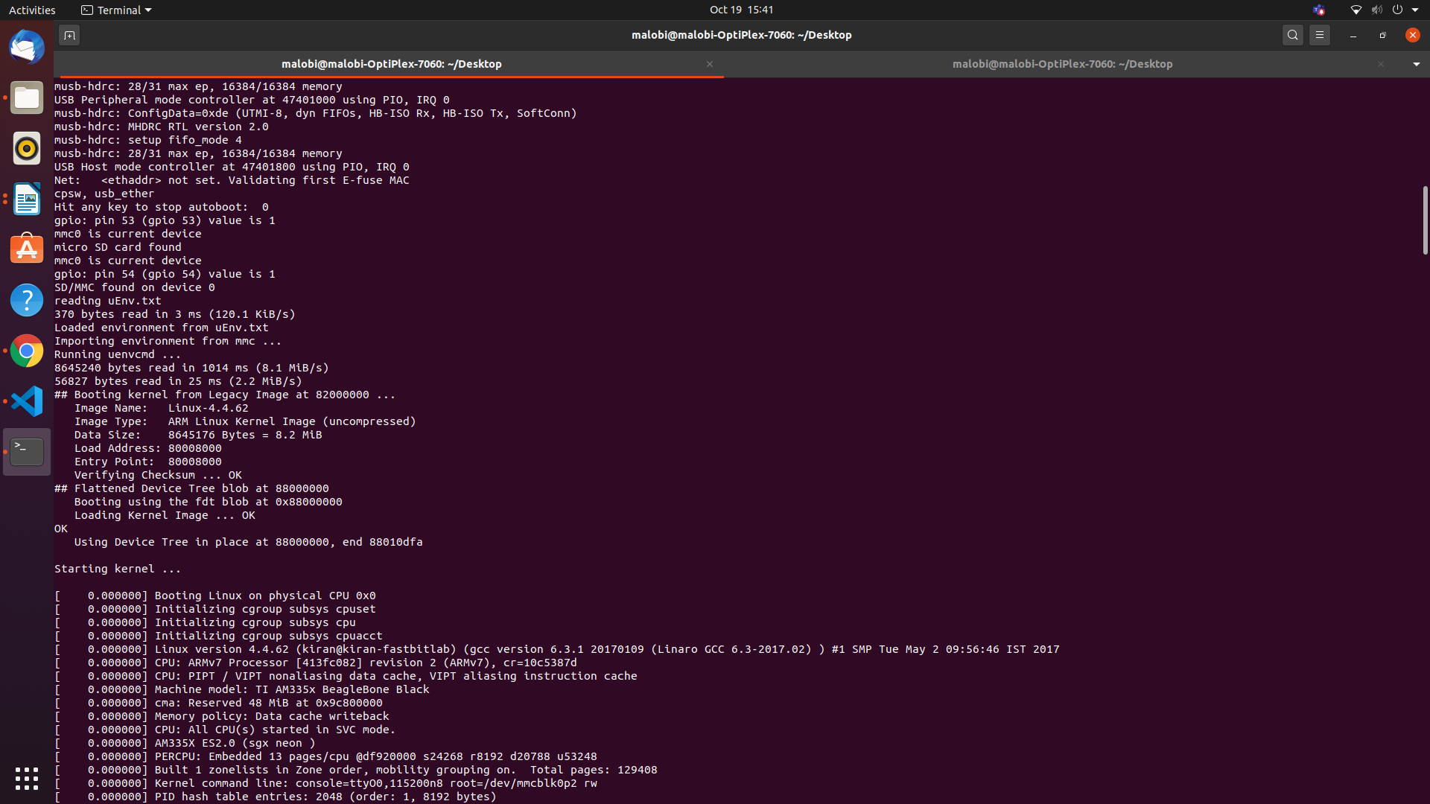

Figure 4: Loading from uEnv.txt

* uBoot will load using a default environment space. This default space includes a variable bootenv=uEnv.txt and associated script that allows additional variables to be added or overwritten by adding them to an uEnv.txt file placed on the FAT partition. uBoot will attempt to load this file and append the extra variables:
* uBoot will then load the Linux Kernel and compiled Device Tree Binary blob from eMMC:
* And boot with the ext4 root filesystem being loaded from /dev/mmcblk0p2

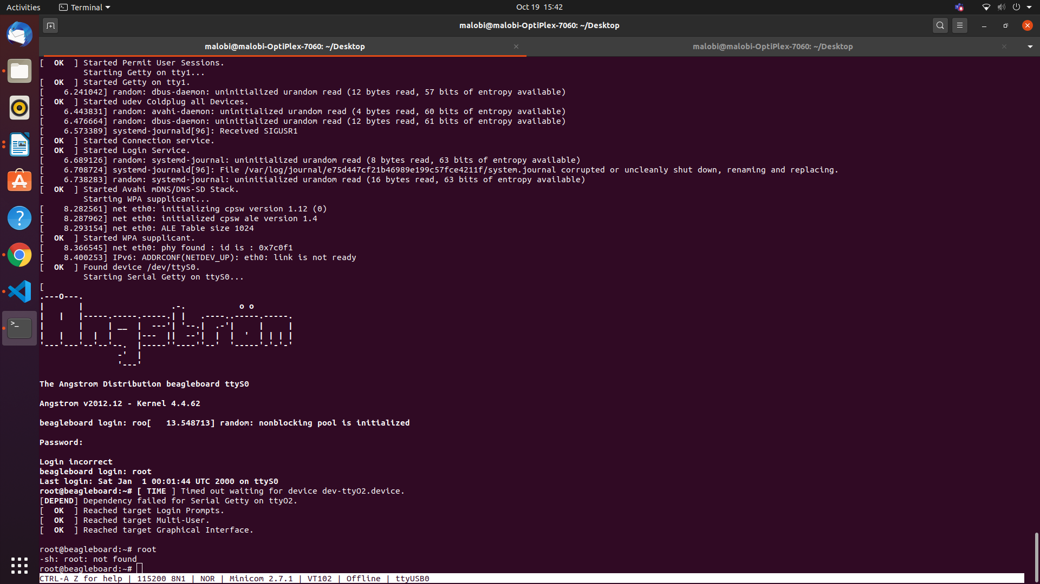

Figure 5: Booting to Kernel Level complete

In this step, the booting process is complete.

# **Activity 8-Challenge-Make uEnv.txt to Boot from MMC0 and MMC 1 .**

* Step 1:

Set IP address of the server with setenv and store inside a variable.

myserverip=setenv serverip=192.168.1.2

* Step 2:

Then set the console and baud rate and also set it the root to read and writable store inside a variable.

Set baud rate as 115200.

* Step 3:

The variable bootm should contain all the booting and loading contents to be taken from the host.

* Step 4:

Bootm should contain mmc value i.e whether eMMC or SD card(mmc 0:2 for sd card and mmc 1:2 for eMMC memory), path and address of uImage, path and address of .dtb file. It can also contain additional comments to be printed.

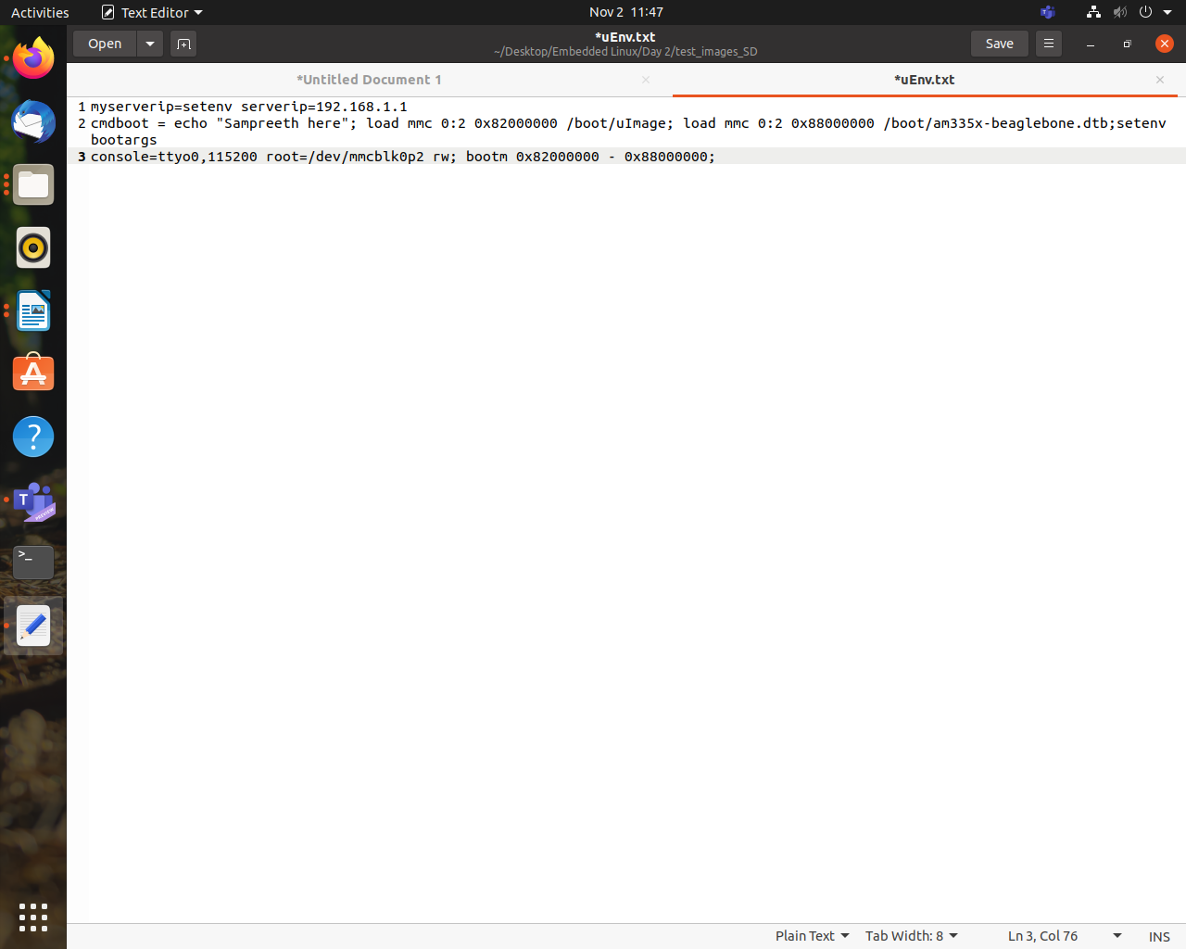

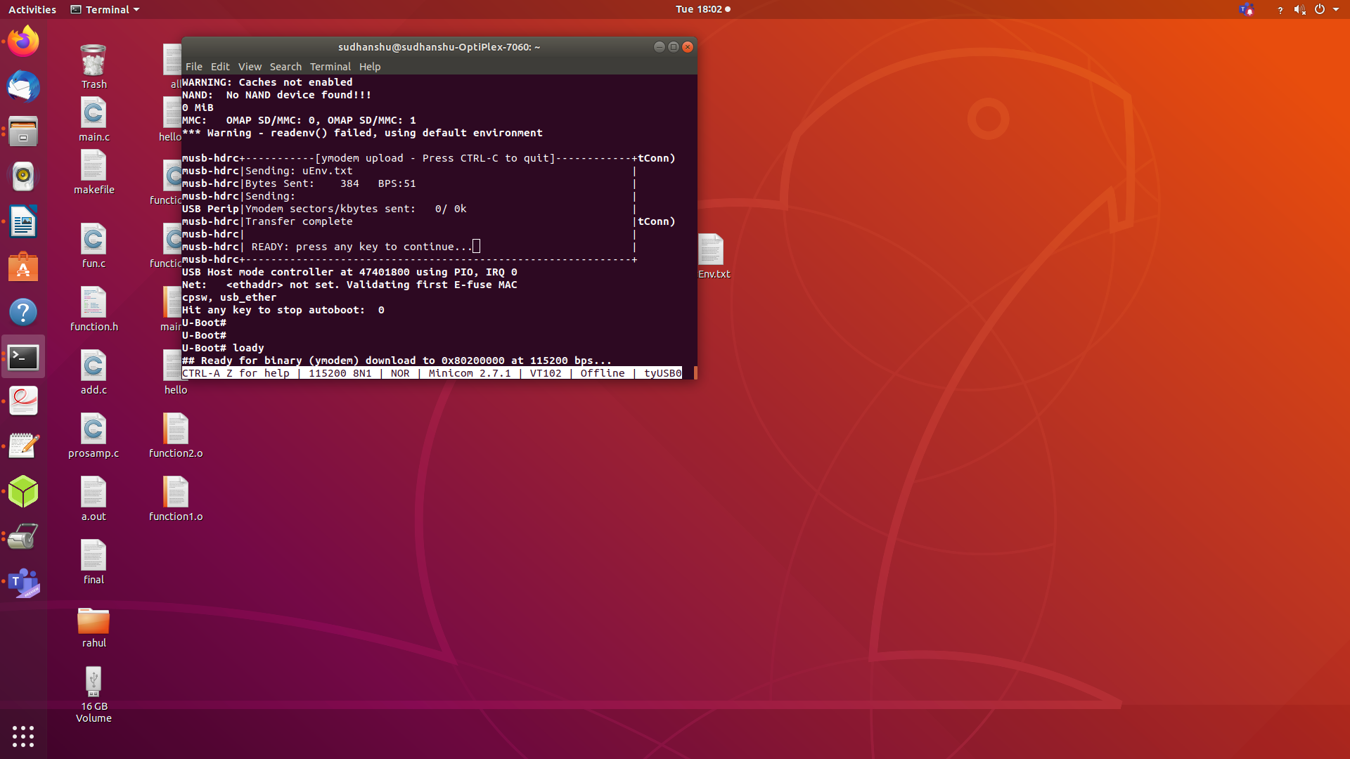

# **Activity 9-Challenge-Write a generic uEnv.txt**



# 

# **Activity 11-Challenge-Increase the AUTOLOAD timings .**

To configure autoload timings, we have to create own u-boot image.

**STEP 1: *distclean*** : deletes all the previously compiled/generated object files.

make ARCH=arm CROSS_COMPILE=arm-linux-gnueabihf- distclean

**STEP 2** : apply board default configuration for uboot

*make ARCH=arm CROSS_COMPILE=arm-linux-gnueabihf- am335x_boneblack_defconfig*

**STEP 3** : run menuconfig.

* + Select the “delay in seconds before atomatically booting” and press spacebar.
  + Enter 10s as the delay and save it.

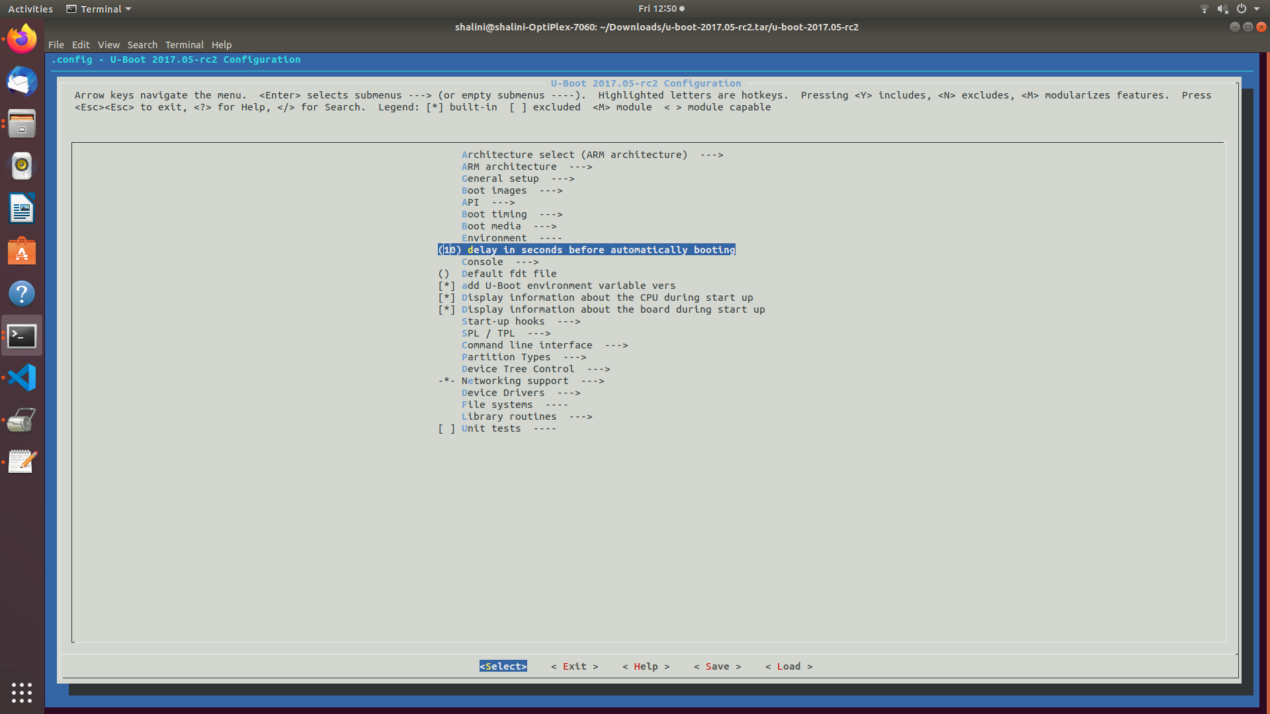

**STEP 4** : compile

make ARCH=arm CROSS_COMPILE=arm-linux-gnueabihf- -j4 // -j4(4 core machine) will instruct the make tool

to spawn 4 threads.

After the compilation, start booting up BBB using serial booting method.

Upload the newly created U-boot.img instead of the old one.

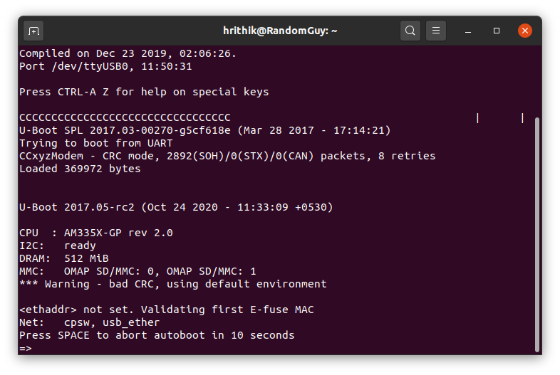

# **Activity 12-Challenge-Busybox "Dynamic" Compilation**

->Static Linking and Static Libraries is the result of the linker making copy of all used library functions to the executable file.

→ Static Linking creates larger binary files, and need more space on disk and main memory. Examples of static libraries (libraries which are statically linked) are, *.a* files in Linux and *.lib* files in Windows.Static libraries occupy lot of space.

→They occupy space in kernel. One more example is when we use printf and scanf in program, the code for printf and scanf is copied into the program before execution which increases the size of the code.

→ Dynamic Linking doesn’t require the code to be copied, it is done by just placing name of the library in the binary file.

→ The actual linking happens when the program is run, when both the binary file and the library are in memory.

→ Examples of Dynamic libraries (libraries which are linked at run-time) are, .so in Linux and .dll in Windows. Dynamic libraries occupy less space. They do not occupy space in kernel.

→ One more example is in dynamic linking is when we use printf and scanf in program, code for printf and scanf is linked during runtime so size of code reduces.

***Steps for Busybox "Dynamic" Compilation***

(open terminal)

**STEP 1:** Download busybox

https://busybox.net/

**STEP 2 :** Clean the earlier files

make ARCH=arm CROSS_COMPILE=arm-linux-gnueabihf- distclean

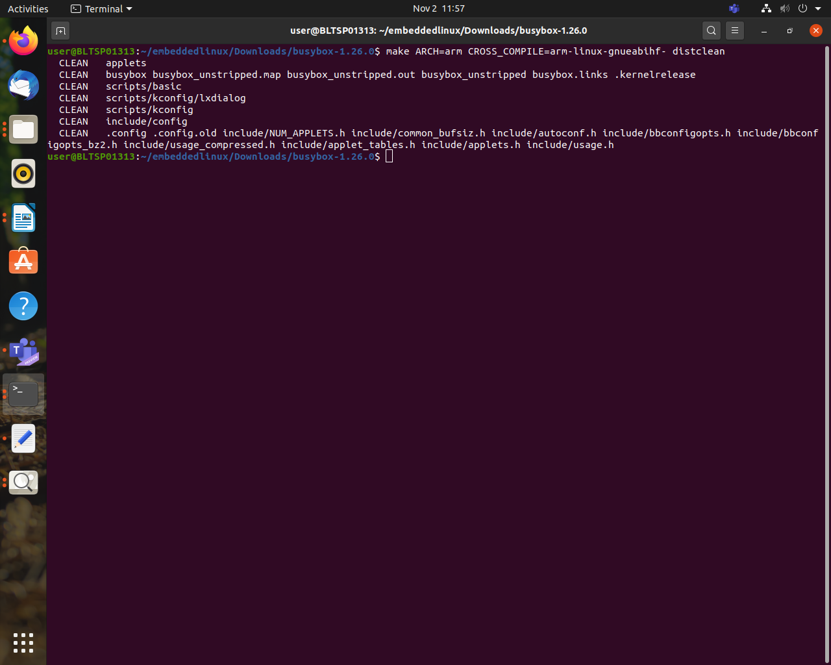

**STEP 3 :** Apply default configuration

make ARCH=arm CROSS_COMPILE=arm-linux-gnueabihf- defconfig

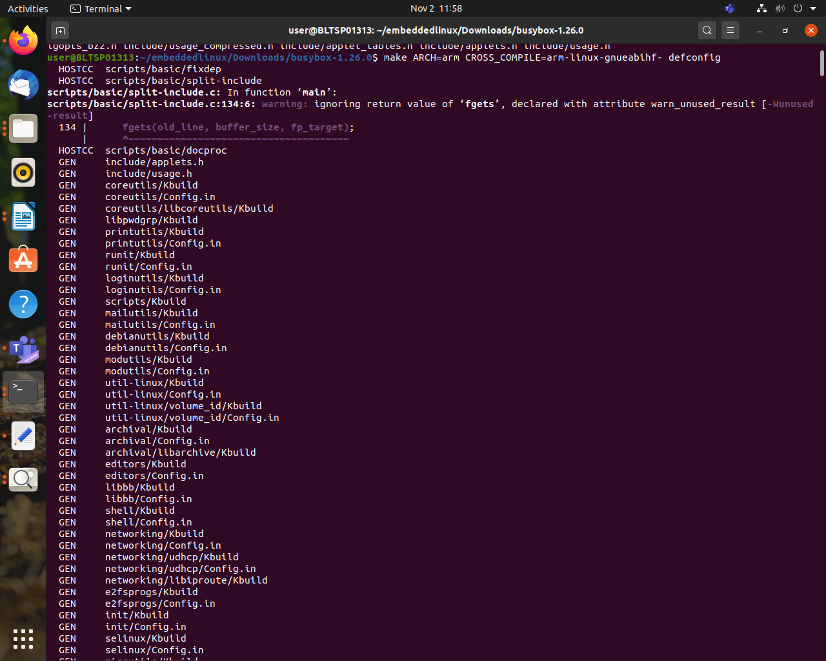

**STEP 4 :** Change default settings.

make ARCH=arm CROSS_COMPILE=arm-linux-gnueabihf- menuconfig

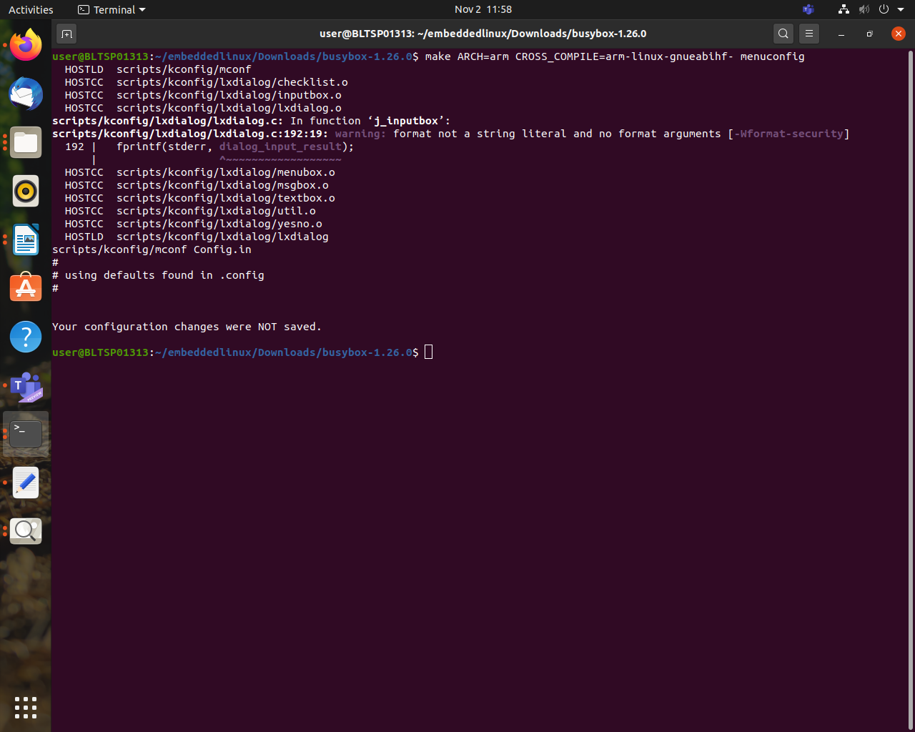

**STEP 5 :**Menu Pops up

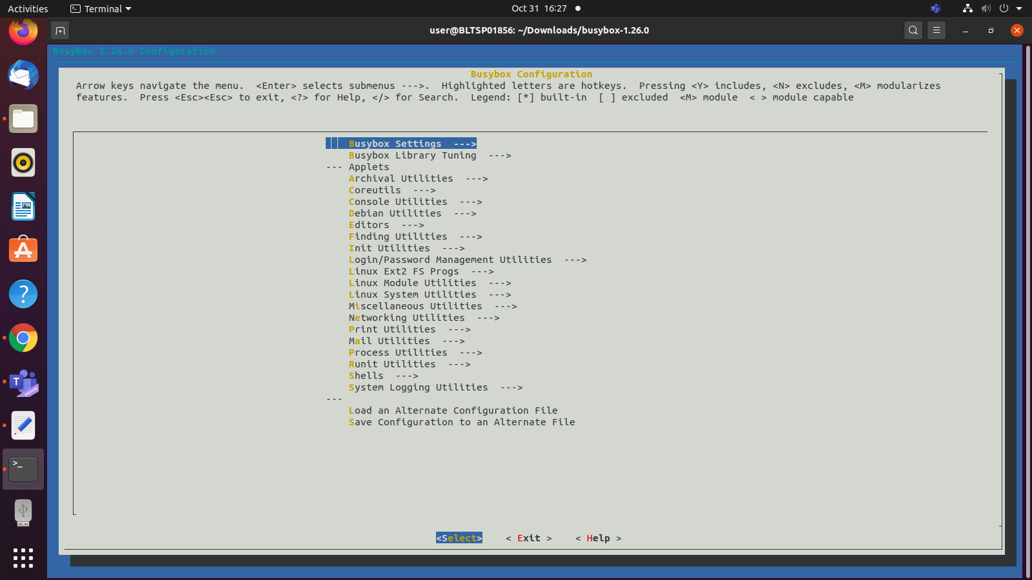

**STEP 6 :** Change default settings.

go in Busybox Setting->Build shared libbusybox

press space and save the setting.

# 

**STEP 7 :** Generate the busy box binary and minimal file system

*make ARCH=arm CROSS_COMPILE=arm-linux-gnueabihf- INSTALL_MOD_PATH=<install_path> modules_install*

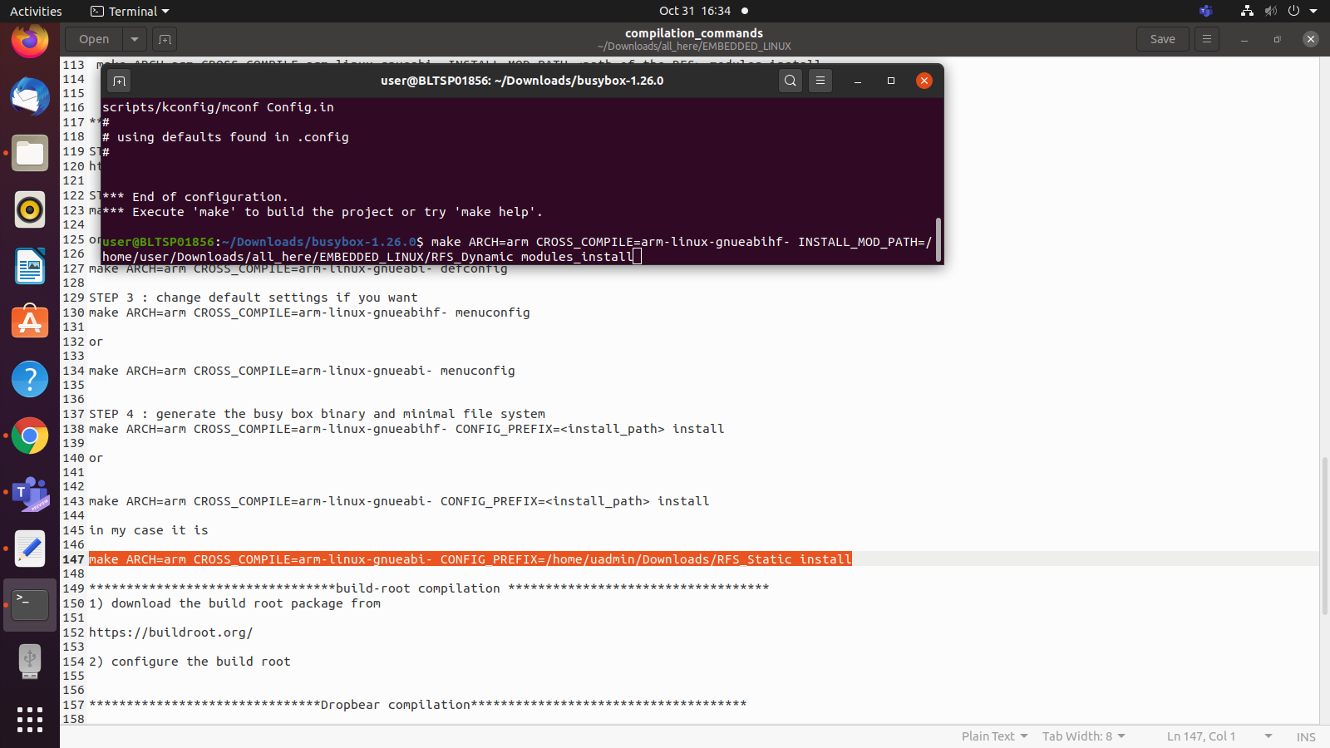

**STEP 7 :** Open terminal in Linux-4.14

*make ARCH=arm CROSS_COMPILE=arm-linux-gnueabihf- INSTALL_MOD_PATH=<path of the RFS> modules_install*

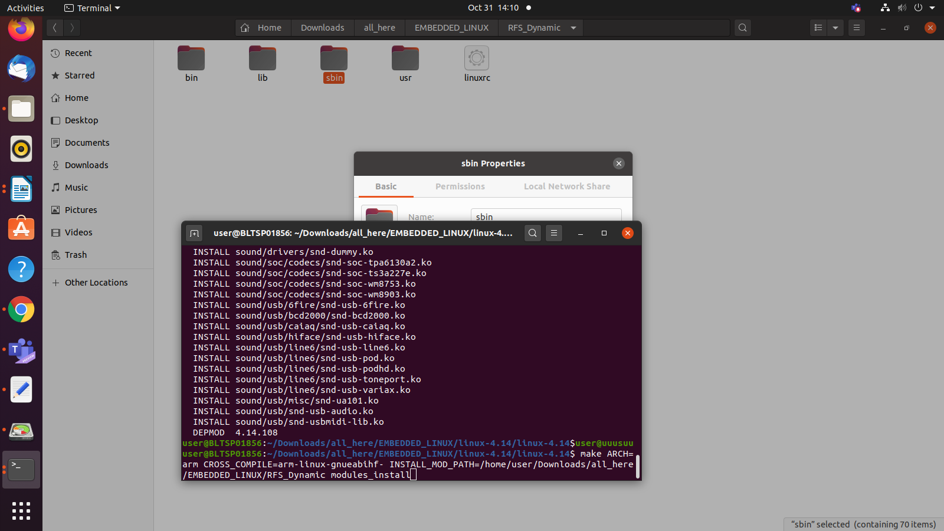

**STEP 8** :Dynamic files is generated. Size is much smaller than static files.

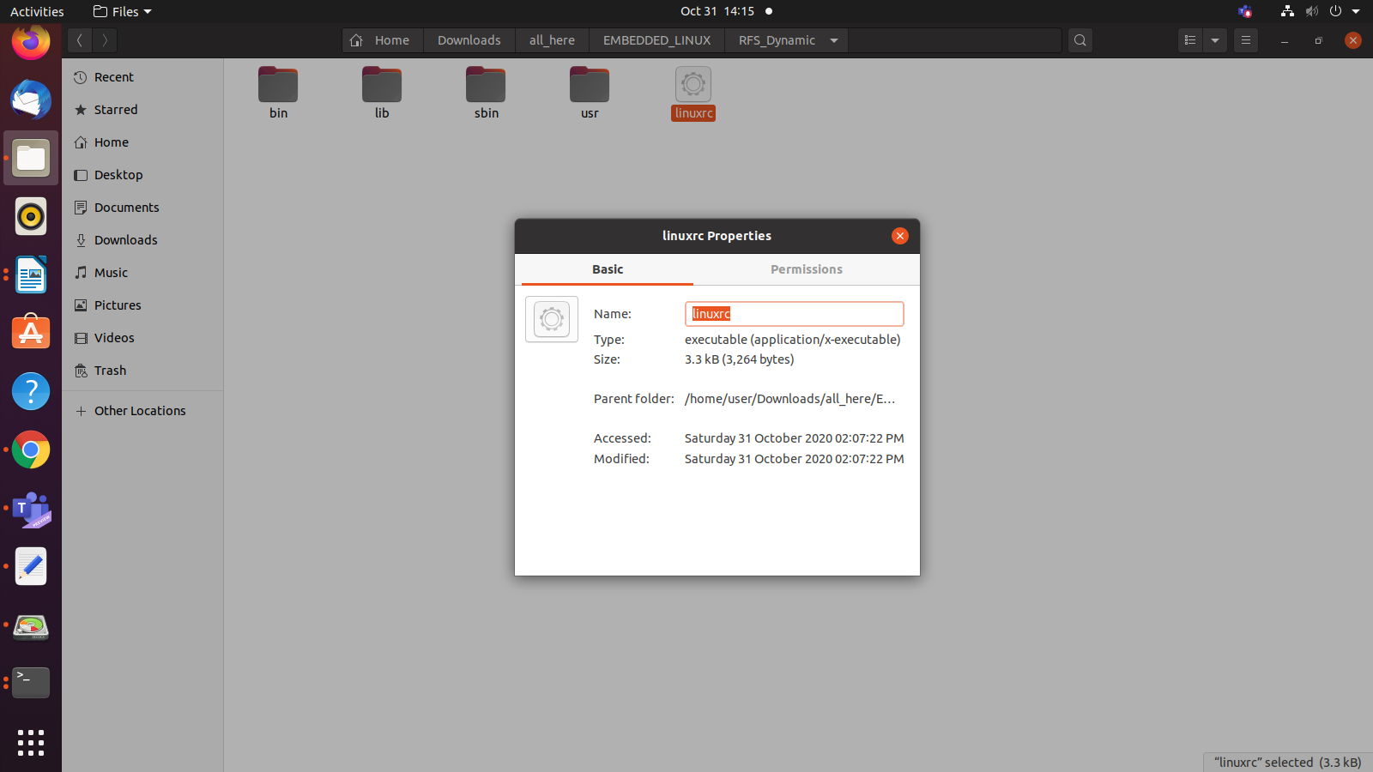

# References

[1]Step by step configuration[https://www.youtube.com/watch?v=UMEUo6Wm6u4& list=PLGs0VKk2Di...](https://www.youtube.com/watch?v=UMEUo6Wm6u4&list=PLGs0VKk2DiYyThNvj6VyDFmOnQ8ncXk8b&index=1)

[2]Step by step configuration-[https://www.youtube.com/watch?v=c81tmb7WJxw&list=PLG s0VKk2Di...](https://www.youtube.com/watch?v=c81tmb7WJxw&list=PLGs0VKk2DiYyThNvj6VyDFmOnQ8ncXk8b&index=2)

[3]Beagleboard-https://beagleboard.org/black

[4]Evolution of BBB-https://elinux.org/Beagleboard:BeagleBoneBlack#Revision_C_. 28Production_Version.29

[5]USB to TTL logic-https://www.robotics.org.za/W7965

[6]TI PROCESSOR-https://www.ti.com/lit/ug/swpu270t/swpu270t.pdf

[7]Different versions of BBB-https://en.wikipedia.org/wiki/BeagleBoard